Black text – Console output

Green Text – User input

Red text - Note

**UPON ENTRY**

---------WELCOME---------

Our application offers the following features:

1. List available media for user

2. Get number of episodes in a season for a TV show

3. Create new payment

4. Create next season

5. Increase ratings of all media with The Rock in it by 1.

6. Quit

**OPTION 1 – List available media for user**

Enter an option number: 1

**Valid Account**

Enter an account ID number: 1

Enter a username: Basta

Available Media:

Breaking Bad (2008)

Pokemon (1999)

Digimon (2001)

**Account ID not int**

Enter an account ID number: string

Invalid input. Returning to main menu.

**Account ID or username doesn’t exist**

Enter an account ID number: 1

Enter a username: NonExistentUser

No available media.

**OPTION 2 – Get number of episodes in a season**

Enter an option number: 2

**Valid TV show and season number**

Enter a TV show title: Pokemon

Enter a season number: 1

Number of episodes in season 1: 2

**Season number not int**

Enter a TV show title: Pokemon

Enter a season number: String

Invalid input. Returning to main menu.

**TV Show or season number doesn’t exist**

Enter a TV show title: NonExistentShow

Enter a season number: 0

Number of episodes in season 0: 0

**OPTION 3 – Create new payment**

Enter an option number: 3

**BEFORE**

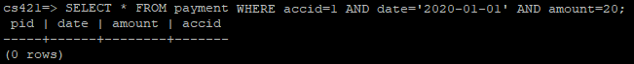

**Valid account ID, date, and amount**

Enter an account ID number: 1

Enter a date: 2020-01-01

Enter an amount: 20

Successfully added payment for account with ID #1 on 2020-01-01 for $20.0.

**AFTER**

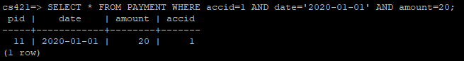

**Account ID not int**

Enter an account ID number: String

Invalid input. Returning to main menu.

**Amount not float**

Enter an account ID number: 1

Enter a date: 2020-01-01

Enter an amount: String

Invalid input. Returning to main menu.

**Date not valid**

Enter an account ID number: 1

Enter a date: InvalidDate

Enter an amount: 20

ERROR: invalid input syntax for type date: "InvalidDate"

Position: 38

Returning to main menu.

**Account ID doesn’t exist**

Enter an account ID number: 2

Enter a date: 2020-01-01

Enter an amount: 20

ERROR: insert or update on table "payment" violates foreign key constraint "payment_accid_fkey"

Detail: Key (accid)=(2) is not present in table "account".

Returning to main menu.

**OPTION 4 – Create next season**

Enter an option number: 4

**BEFORE**

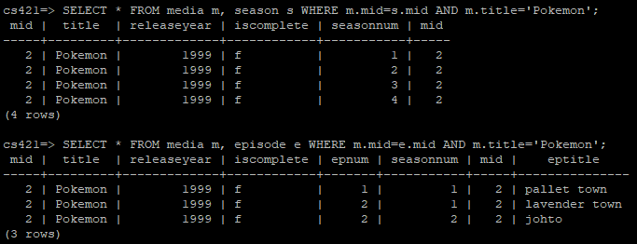

**Valid TV show name**

Enter a TV show title: Pokemon

Your new season needs at least one episode. Enter an episode title: Title

Successfully added season 5 to Pokemon with first episode "Title".

**\*\*\* NOTE: CREATES NEXT SEQUENTIAL SEASON AND CREATES EPISODE 1 OF THAT SEASON \*\*\***

**AFTER**

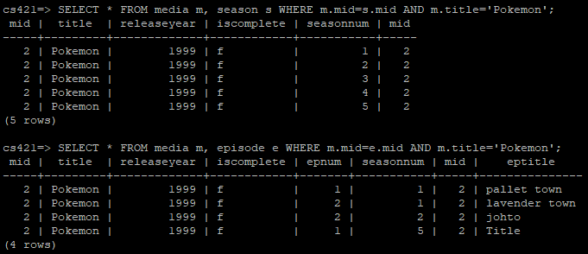

**TV show does not exist**

Enter a TV show title: NonExistentShow

Your new season needs at least one episode. Enter an episode title: Title

ERROR: Show does not exist.

Returning to main menu.

**OPTION 5 – Increase ratings of all media with The Rock in it by 1**

Enter an option number: 5

**BEFORE**

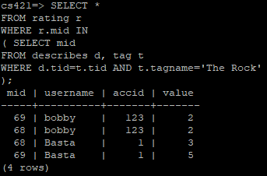

**AFTER**

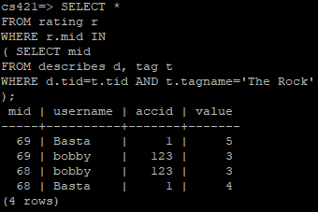

**\*\*\* NOTE: If value was already 5 it doesn’t change \*\*\***

**OPTION 6 – Quit**

Enter an option number: 6

---------GOODBYE---------